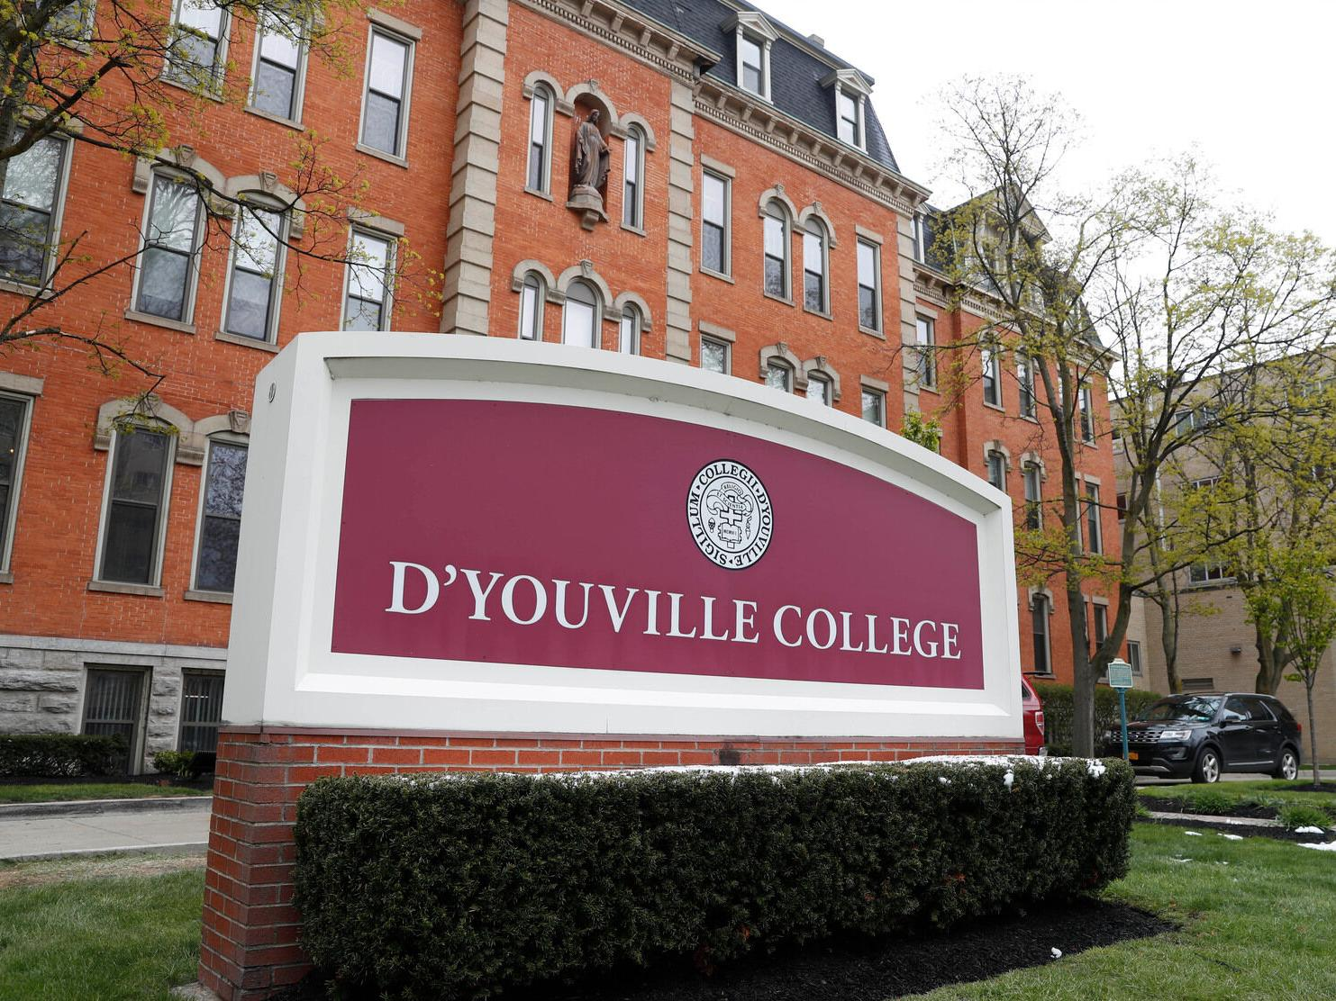

MINIMUM CAPACITY :-
The Minumum intake capacity
of students is between 150-350
children

LIBRARY :-
The Libarary is Available.

CANTEEN:-
The Canteen Facility is Available.

BOARDING :-
No availablility of boarding.

SPORTS :-
There are different categories
sports available.
Girls Volleyball
Boys Volleyball
Football

D'YOUVILLE COLLEGE
BUFFALO - SCHOOL

School Detail :-
D'Youville University is a private university in Buffalo, New York. It was founded as D'Youville College in 1908 and named by the Grey Nuns after the patroness saint Marie-Marguerite d'Youville.
Located in Western New York on the Lower West Side of the City of Buffalo, the campus is in an urban setting a few blocks from the Peace Bridge on the Canadian border. The campus has 15 buildings with classrooms, laboratories, residential and athletics facilities. There are two student housing buildings and one outdoor athletics complex.

